Test 1. TCP/IP Configuration

1. Click Start and then click Run. Type the command or cmd and then press Enter.
2. At the DOS prompt, type NET HELP and press Enter. You should see something like the screen below:
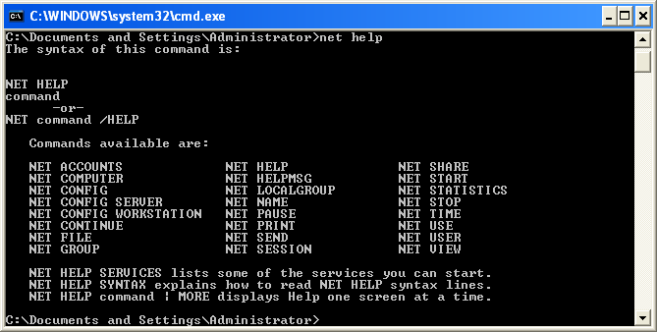

The command you are interested in is the View command. To obtain information about it, type NET HELP VIEW, and press Enter.

3. What is the purpose of NET VIEW:

______________________________________________________________________________________________________________________________________________________________________________________________________________________________________________________________________________________________________________________

The NET VIEW command shows the names of the machines present on your network. Notice that it lists the names of machines on the left, in column labelled “Server name” and another column labelled “Remark”

4. List the machines after you have typed NET VIEW from the command prompt
_____________________________________________________________________________________________________________________________________________________________________________________________________________________________________________________________________________________________________________________________________________
Close the DOS window by typing EXIT on the command line and then press Enter, or by clicking the Close button in the upper right corner of the window.

Obtain the TCP/IP Configuration Information
Use the Start menu to open the Command Prompt, an MS-DOS-like window. Press Start > Programs > Accessories > Command Prompt or Start > Programs > Command Prompt.

The following figure shows the Command screen. Type ipconfig and press the Enter key. The spelling of ipconfig is critical while case is not. It is short for IP Configuration.

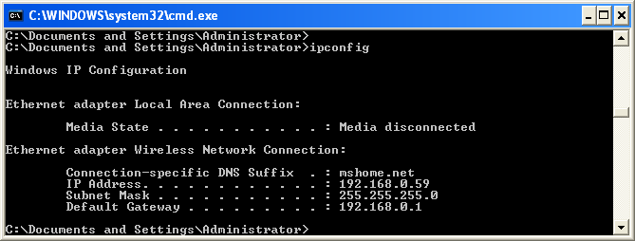

This first screen shows the IP address, subnet mask, and default gateway. The IP address and the default gateway should be in the same network or subnet, otherwise this host would not be able to communicate outside the network. In the figure the subnet mask tells us that the first three octets must be the same to be in the same network.

Note: If this computer is on a LAN, the default gateway might not be seen if it is running behind a Proxy Server. Record the following information for this computer.

Record the following TCP/IP information for this computer
6.IP address: __________________________________________________
Subnet Mask: ________________________________________________
Default Gateway: ____________________________________________

Compare the TCP/IP configuration of this computer to others on the LAN
7.If this computer is on a LAN, compare the information of several machines.
Record a couple of the IP Addresses:
1) IP sddresses 1: _______________

2) IP addresses 2: _______________
Are there any similarities? ______________________________________________________

What is similar about the IP addresses? ____________________________________________

What is similar about the default gateways? _________________________________________

The IP addresses should share the same network portion. All machines in the LAN should share the same default gateway.

Check additional TCP/IP configuration information
To see detailed information, type ipconfig /all and press Enter. The figure shows the detailed IP configuration screen.
The host name, including the computer name and NetBIOS name should be displayed. Also, the DHCP server address, if used, and the date the IP lease starts and ends should be displayed. Look over the information. Entries for the DNS, used in name resolution servers, may also be present.

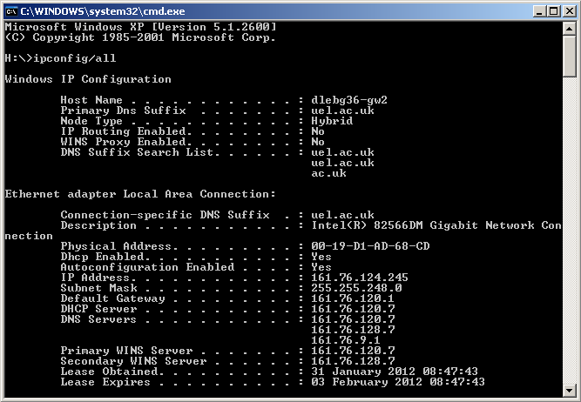

8.Mark the Physical Address (MAC) and the NIC model (Description).
________________________________________________________________________________________________________________________________________________________________________________________________________________________________________________________

9.While not a requirement, most LAN administrators try to standardize components like NICs. Therefore, it would not be surprising to find all machines share the first three Hex pairs in the adapter address. These three pairs identify the manufacturer of the adapter.
____________________
10.Write down the IP addresses of any servers listed (if any):
______________________________________________________________________________________________________________________________________

Write down the computer Host Name:
___________________________________________________________________

Write down the Host Names of a couple other computers:
___________________________________________________________________

Do all of the servers and workstations share the same network portion of the IP address as the student workstation? ____________________

It would not be unusual for some or all of the servers and workstations to be in another network. It means that the computer default gateway is going to forward requests to the other network.

Using ping from a Workstation

Access the command prompt

Use the Start menu to open the Command Prompt window. Press Start > Programs > Accessories > Command Prompt or Start > Programs > Command Prompt or Start > All Programs > Command Prompt.

ping the IP address of another computer
In the window, type ping, a space, and the IP address of a computer located in your working area .

11.The following figure shows the successful results of ping to this IP address.
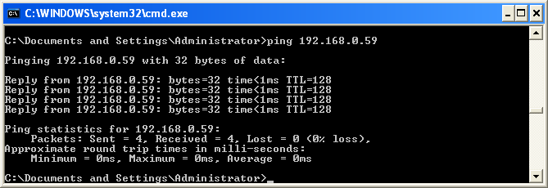

Ping uses the ICMP echo request and echo reply feature to test physical connectivity. Since ping reports on four attempts, it gives an indication of the reliability of the connection. Look over the results and verify that the ping was successful. Is the ping successful? If not, perform appropriate troubleshooting. ____________________

If a second networked computer is available, try to ping the IP address of the second machine.
Note the results. __________________________________________

ping the IP address of a DHCP or DNS servers
12.Try to ping the IP address of any DHCP and/or DNS servers listed in the last exercise. If this works for either server, and they are not in the network, what does this indicate?
______________________________________________________________
Was the ping successful? ____________________

ping the hostname of another computer
Try to ping the hostname of the computer that was recorded previously. The figure shows the successful result of the ping the hostname.
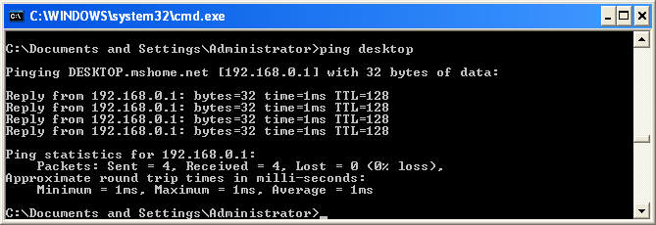

Look over the results. Notice that the first line of output shows the host name, DESKTOP in the example, followed by the IP address. This means the computer was able to resolve the host name to an IP address. Without name resolution, the ping would have failed because TCP/IP only understands valid IP addresses, not names.

If the ping was successful, it means that connectivity and discovery of IP addresses can be done with only a hostname. In fact, this is how many early networks communicated. If successful, then ping a hostname also shows that there is probably a WINS server working on the network. WINS servers or a local “lmhosts” file resolve computer host names to IP addresses. If the ping fails, then chances are there is no NetBIOS name to IP addresses resolution running.

ping the IP address of the default gateway

13.What is the IP address of your default gateway?
__________________________________

Try to ping the IP address of the default gateway. Was it successful? _______

If the ping is successful, it means there is physical connectivity to the router on the local network and probably the rest of the world.
Type tracert at the command prompt, followed by a host name or IP address from your working area.

tracert is TCP/IP abbreviation for trace route. The preceding figure shows the successful result when running tracert from on a LAN. The first output line shows the FQDN followed by the IP address. Therefore, a DNS server was able to resolve the name to an IP address. If you are connected on a huge network (like the Internet) there will be listings of all routers the tracert requests had to pass through to get to the destination.
tracert uses the same echo requests and replies as the ping command but in a slightly different way.

Each router represents a point where one network connects to another network and the packet was forwarded through.
14. Tracert a website and explain what you have found.
________________________________________________________________________________________________________________________________________________________________________________________________________________________________________________________

